### STUDENT NAME : ***YASH GUPTA***

### UID: ***20BCS5009*** BRANCH: ***B.E CSE***

### SECTION/GROUP: ***CSE 34/B***

# AIM:

Design a home appliance control system with 3-to-8 decoder.

# TASK TO BE DONE:

In this experiment, we will be able learn about Decoder. Also, learn how Decoder works and by how changing the Inputs different appliances can be made turn on and off.

# Requirements:

74LS138 IC, 10K Ohms resistances, LED’s, +5v Power Supply, Bread Board, Connecting Wires.

# Circuit diagram/ Block diagram:

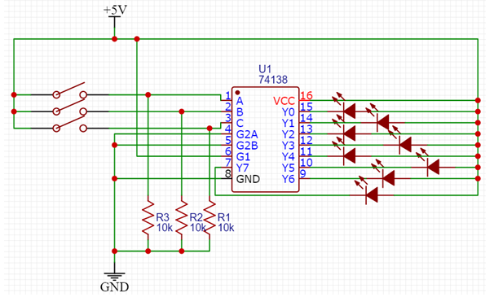

# Simulating **Results:**

***When Simulation has not started***

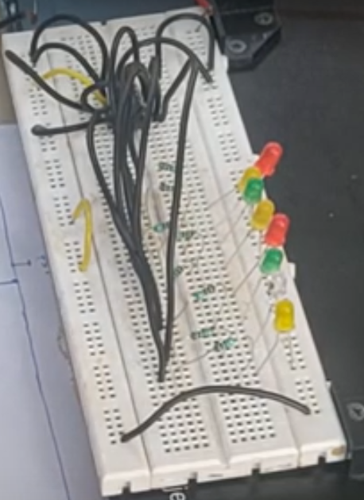

***When first light is not glowed***

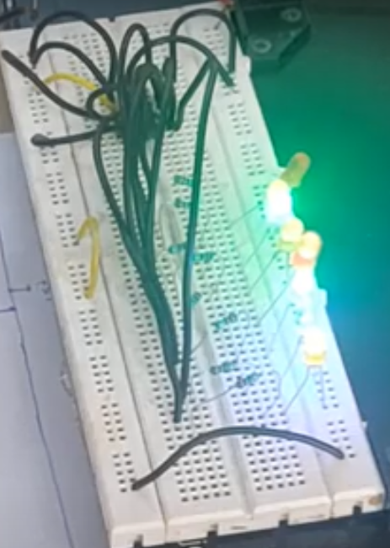

***When second light is not glowed***

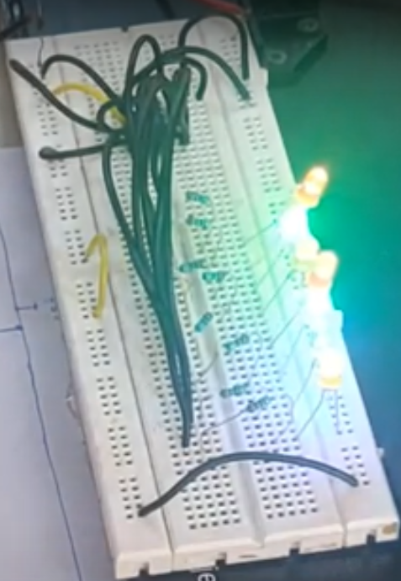

# CONCEPT USED:

The memory unit data exchange rate determines the performance of any application and the delays of any kind are not tolerable there. In such applications using 74LS138 line decoder is ideal. This means that the effective system delay introduced by the decoder is negligible to affect the performance.

# Learning/Observation:

The chip is specifically designed to be used in high-performance memory-decoding or data - routing applications which require very short propagation delay times. Home appliance control system has been Designed and Implemented using 3 to 8 Decoder.

# Trouble shooting:

If you not place a resistor on this circuit, ic will be damaged. So, to prevent from the damage we have to place resistors over there which will helping or controlling the flow of voltage.